


BEFORE SCHOOL | TERM 1 WEEK 3
LEARNING AREAS |  |  | MONDAY | TUESDAY | WEDNESDAY | THURSDAY | FRIDAY
CREATE |  |  | 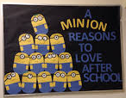  Make A Minion | 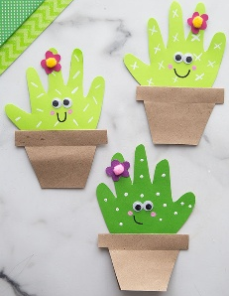  Cactus Hands | 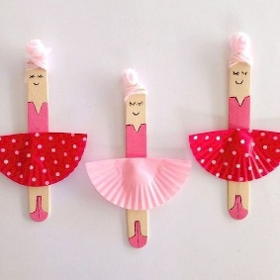  Ballerina Popsicle Sticks |   Valentines Day Bow Garland | 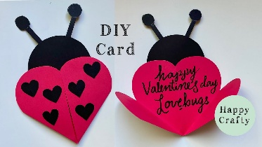  Valentines Day Cards
 |  |  | MTOP: 4.2 | MTOP: 1.2 | MTOP: 4.4 | MTOP: 4.3 | MTOP: 1.3
EXPERIENCES AND SPORT | Room Activity |  | Train Tracks  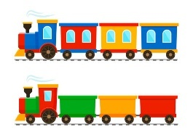 |   Blooket | Drawing Tutorials  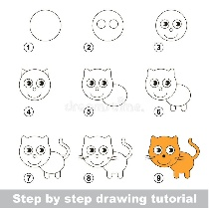 | Spot It!  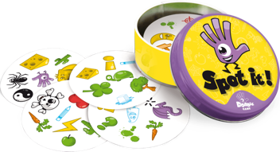 | Mario Jamboree  
 |  |  | MTOP: 1.1 | MTOP: 5.3 | MTOP: 5.3 | MTOP: 1.3 | MTOP: 5.3
 | All Ages Physical |  | Cricket   | Stuck In the Mud   | Obstacle Course   | Oztag- CS: Micah, Y5   | Nerf Guns  
 |  |  | MTOP: 3.1 | MTOP: 3.2 | MTOP: 4.2 | MTOP: 1.4 | MTOP: 4.1
JNR Activity |  |  | Handball | Dodgeball | Soccer - Astro | Musical Chairs | Positive Chalk Affirmations
 |  |  | MTOP: 2.3 | MTOP: 3.2 | MTOP: 3.2 | MTOP: 1.4 | MTOP: 1.1
SNR Activity |  |  | Netball | Soccer- Astro | Dodgeball | Axe Throwing | Handball
 |  |  | MTOP: 2.1 | MTOP: 2.3 | MTOP: 3.2 | MTOP: 4.2 | MTOP: 2.3
AFTER SCHOOL| TERM 1 WEEK 3 |Preps & Ones
Weekly Focus Area:
Day | Books of the Week | Craft/Club |  | Group Game |  | Outdoor Activity |  | Extra Activity
Monday | 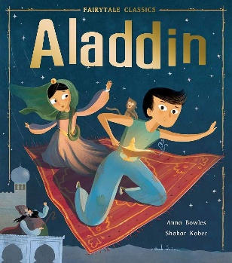  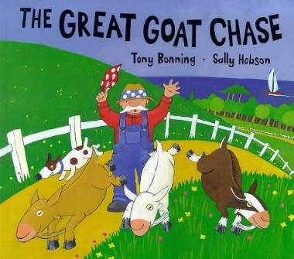  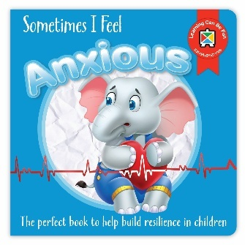    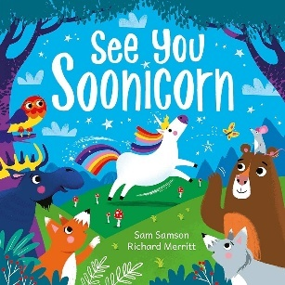 | 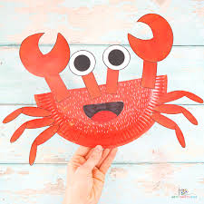  Paper Plate Crabs |  | Parachute Games   |  | Building Blocks   |  | Ring Toss  
Monday |  | MTOP: 1.4 |  | MTOP: 1.1 |  | MTOP: 4.2 |  | MTOP: 4.1
Tuesday |  | 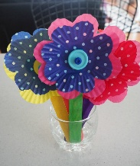  Patty Case Flowers |  | Lava Monster   |  |   Skipping |  | Sandpit Creations  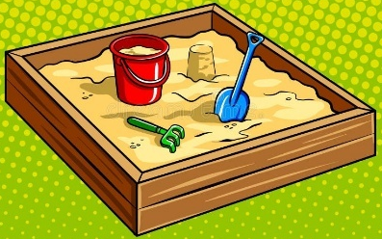
Tuesday |  | MTOP: 1.2 |  | MTOP: 1.3 |  | MTOP: 3.2 |  | MTOP: 1.1
Wednesday |  | Oil Pastel Butterflies  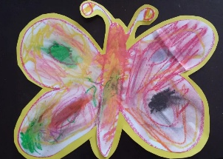 |  | 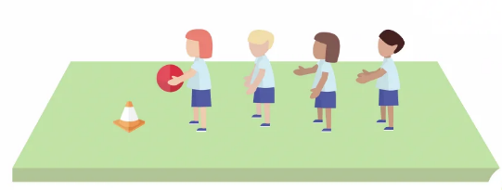  Tunnel Ball |  |   Dress Ups |  | Imaginative Doll House Playing  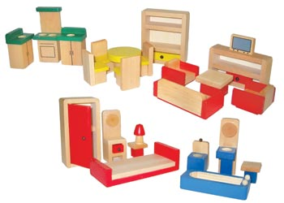
Wednesday |  | MTOP: 2.3 |  | MTOP: 2.1 |  | MTOP: 1.1 |  | MTOP: 1.1
Thursday |  | 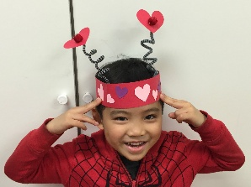  Love Bug Hats |  | Duck, Duck, Goose  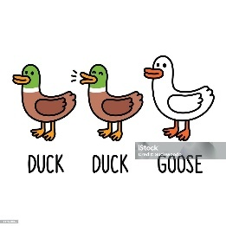 |  | Bug watching & finding   |  | Lego  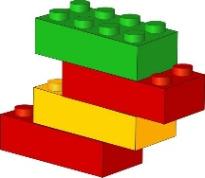
Thursday |  | MTOP: 1.1 |  | MTOP: 1.3 |  | MTOP: 4.2 |  | MTOP: 4.4
Friday |  | Positive Affirmations Colouring ins   |  |   Red Rover |  |   Sack Races |  | Soccer  
Friday |  | MTOP: 2.3 |  | MTOP: 3.2 |  | MTOP: 1.1 |  | MTOP: 2.1
AFTER SCHOOL | TERM 1 WEEK 3 | Year 2 & 3
Weekly Focus Area:
Day | Extra Activity |  | Craft/Club | Group Game | Outdoor Activity |  | Free Play Area/Club
Monday | Handball  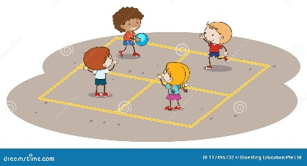 |  | 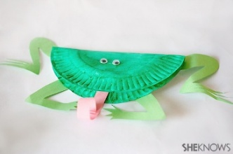  Paper Plate Frog | 4 Corners   | Pickleball  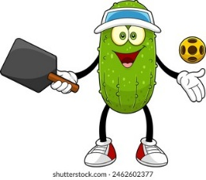 |  | MPC & COURTS
Monday | MTOP: 2.2 |  | MTOP: 1.4 | MTOP: 4.2 | MTOP: 3.1
Tuesday | Hill Sledding  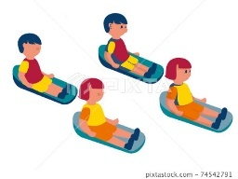 |  | 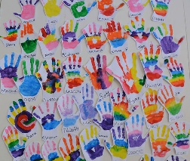  Rainbow Handprints | Over & Under Relay   | Oztag |  | OVAL & OSHC ROOM
Tuesday | MTOP: 1.1 |  | MTOP: 1.2 | MTOP: 1.4 | MTOP: 3.2 |  | MTOP: 5.1
Wednesday | Skipping & Hula hoops – CS: Mabel, Y3 |  | Window Paintings  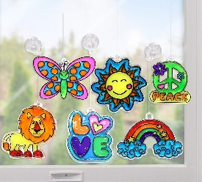 | Sack Races | Soccer Drills |  | GRASSY & ASTRO    Gardening Club w/ Ms. Kim
Wednesday | MTOP: 1.1 |  | MTOP: 2.3 | MTOP: 1.2 | MTOP: 3.2
Thursday | Ring toss |  | Love Bugs   | Dodgeball   | Cricket |  | Chess & Chill Club w/ Owen & Alex  
Thursday | MTOP: 4.1 |  | MTOP: 1.1 | MTOP: 3.1 | MTOP: 3.2 |  | MPC & COURTS
Friday | Hula Hoop Challenge   |  | Valentines Day Flowers   | 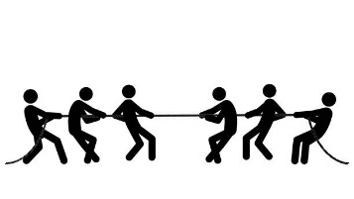  Tug Of War | Loose Parts  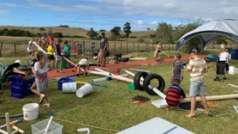 |  | OVAL & OSHC ROOM
Friday | MTOP: 2.1 |  | MTOP: 2.3 | MTOP: 2.1 | MTOP: 4.4 |  | MTOP: 3.2
AFTER SCHOOL | TERM 1 WEEK 3|Year 4, 5 & 6
Weekly Focus Area:
Day | Craft |  | Group Game | Outdoor Activity |  | Free Play Area | Clubs/Extra Responsibilities
Monday | Paper Plate Frog |  | Oztag – CS: Eva M, Y5 | Gymnastic Mats   |  | OVAL
Monday | MTOP: 1.4 |  | MTOP: 1.2 | MTOP: 1.1 |  |  | MTOP: 3.2
Tuesday | Rainbow Handprints |  | Cricket | Pickleball  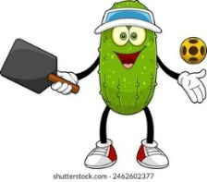 |  | MPC & COURTS
Tuesday | MTOP: 1.2 |  | MTOP: 2.1 | MTOP: 1.3 |  | MTOP: 2.3 | MTOP: 5.1
Wednesday | Window Paintings |  | Markers Up   | Loose Parts  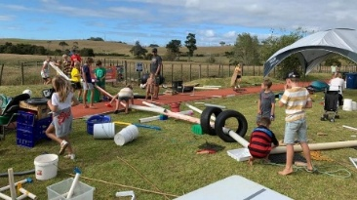 |  | OVAL |   Gardening Club w/ Ms. Kim
Wednesday | MTOP: 2.3 |  | MTOP: 3.2 | MTOP: 4.4 |  | MTOP: 2.3 | MTOP: 5.1
Thursday | Love Bugs |  | Volleyball   | Soccer Match – CS: Malakai, Y5 |  | Astro & Grassy  Undercover Area | Chess & Chill Club w/ Owen & Alex
Thursday | MTOP: 1.1 |  | MTOP: 2.1 | MTOP: 1.2 |  | MTOP: 2.3 | MTOP: 5.1
Friday | Valentines Day Flowers   |  | Dodgeball | Cops & Robbers   |  | MPC & COURTS
Friday | MTOP: 2.3 |  | MTOP: 3.1 | MTOP: 3.2 |  |  | MTOP: 3.2

